Invention Disclosure Form

- Describe the invention.
1a. Describe the invention in your own words. Is the invention a new process, composition of matter, device or product, system, software, or a combination of these elements?

The project invention mainly focuses to addressing the pressing need for enhanced charging infrastructure in the rapidly growing electric vehicle (EV) market. As the adoption of EVs increases, the existing charging systems, which are often connected to the grid, face challenges such as sudden load disturbances, lack of real-time power demand data, high installation and operational costs, and inefficient load management. To tackle these issues, the proposed method is a novel system that aims to enhance the efficiency and stability of (EV) charging infrastructure. It integrates various elements, including hardware, software, and processes, to create a comprehensive solution for managing the charging of EV. The system combines renewable energy sources such as solar power and energy storage systems with grid power to optimize charging operations.

This invention is characterized by its innovative IoT architecture, which consists of five layers: a [1]Device Layer that includes sensors and actuators for real-time data collection; [2]a Network Layer that employs communication protocols like MQTT and HTTP; [3]an Edge Computing Layer for local data processing; [4]a Cloud Layer that utilizes AWS for data storage and analytics; and [5]an Application Layer that provides user interfaces for monitoring and management.

The system also incorporates automation conditions that allow it to adapt to varying energy availability, ensuring efficient load management. By utilizing this integrated approach with the PCC point of common coupling, the invention significantly improves energy savings and cost efficiencies in EV charging operations. Overall, this invention represents a combination of a system designed to address the current challenges in EV charging infrastructure, making it an important advancement in the field.

Title: Design of IoT Architecture for Battery Charging Management System

1b. Does the invention provide a new use of, or an improvement to, an existing product or process?
The invention in the project provides a significant improvement to existing charging systems for electric vehicles (EVs) by integrating an innovative IoT architecture that enhances efficiency and stability. While traditional EV charging solutions often rely on basic grid connections and lack real-time data management, this invention introduces a optimal system that combines renewable energy sources, energy storage systems, and grid power to optimize charging operations.
This invention is not merely a new application of existing technologies; it represents a novel approach to managing the complexities of EV charging. By employing a five-layer IoT architecture - comprising device, network, edge computing, cloud, and application layers—the system allows for real-time monitoring, data analysis, and automation of charging processes. This results in reduced operational costs, improved load management, and minimized waste associated with energy consumption.

- The invention addresses critical issues such as grid disturbances and high operational costs by enabling adaptive responses to varying energy availability.
- The unique automation conditions allow the system to switch between different energy sources based on real-time data, ensuring efficient load distribution and enhanced performance.
- This innovation also improves upon existing EV charging processes but also introduces a comprehensive solution that leverages IoT technology to create a more sustainable and economically viable charging infrastructure.

- From the description, identify and provide a detailed description of specific novel and unusual features.

The Patent introduces several novel and unusual features that enhance the EV charging infrastructure.

- The key innovations include an integrated five-layer IoT architecture that allows for improved monitoring and management of charging processes.
- Device Layer: Utilizes sensors and actuators for real-time data collection at charging stations.
- Network Layer: Implements communication protocols like MQTT and HTTP to facilitate data transmission.
- Edge Computing Layer: Allows for local processing of data, enabling immediate decision-making.
- Cloud Layer: Leverages cloud computing services (e.g., AWS) for data storage and advanced analytics.
- Application Layer: Provides user-friendly interfaces for monitoring and controlling the charging process.

- The system is designed to operate under various conditions based on the availability of energy sources. This adaptability allows it to switch between solar energy, energy storage systems (ESS), and grid power, optimizing load management and enhancing operational efficiency.

- The system is designed to automatically adjust its operational parameters based on real-time data inputs regarding energy availability and demand with the Point of common coupling for the integration and automation.
- Solar – ON ESS Charge Grid OFF Load ON
- Solar – ON ESS >80% Grid ON Load ON
- Solar – OFF ESS ON Grid OFF Load ON
- Solar – OFF ESS <20% Grid ON Load ON
- Solar – OFF ESS Charging Grid ON Load OFF

- It includes algorithms for real-time monitoring of solar energy production, battery charging processes for swapping station and DC fast charging, and overall system performance. This feature provides users with actionable insights and alerts, improving the management of energy resources.

- The Cloud Integration is the use of cloud computing that facilitates remote monitoring and control, allowing users to access performance metrics and manage the Data storage and warning alerts.

- By integrating multiple energy sources and utilizing real-time data, the system can effectively manage load distribution. This capability reduces the risk of grid disturbances caused by sudden spikes in demand.

- The innovative approach significantly reduces the operational costs associated with EV charging infrastructure by minimizing waste and optimizing resource utilization. The ability to adaptively manage energy sources leads to substantial savings in both energy consumption and operational expenses.

The Uniqueness of our invention:
- The system intelligently allocates energy from solar, energy storage, and grid sources based on real-time demand, optimizing resource use, and enhancing resilience.
- It incorporates algorithms that monitor charging station health, predicting potential failures to minimize downtime and maintenance costs.
- Users can customize charging schedules and preferences through the application layer, improving their experience and optimizing energy usage.
- The system integrates with smart grid technologies, allowing it to adjust operations based on grid conditions and participate in demand response programs, contributing to grid stability and potential cost savings.

- How does the invention differ from present technology? What problems does it solve, or what advantages does it possess?

The invention represents a significant advancement in EV charging technology by integrating multiple innovative features that differentiate it from existing systems. This comprehensive system combines hardware, software, and processes to optimize the management of EV charging by utilizing a blend of renewable energy sources, energy storage systems, and grid power. Its architecture is structured into several layers: a Device Layer that collects real-time data through sensors and actuators at charging stations, a Network Layer that facilitates communication using protocols like MQTT and HTTP, an Edge Computing Layer that processes data locally for immediate decision-making, a Cloud Layer that offers robust data storage and analytics capabilities, and an Application Layer that provides user-friendly interfaces for monitoring and control.

One of the key innovations of this invention is its smart energy distribution mechanism, which intelligently allocates energy from various sources based on real-time demand and availability. This capability not only ensures optimal resource utilization but also reduces dependence on any single energy source, enhancing the overall resilience of the charging infrastructure. Additionally, the system incorporates predictive maintenance algorithms that continuously monitor the health of charging stations. By anticipating potential failures before they occur, this proactive approach minimizes downtime and maintenance costs, ensuring that the charging infrastructure remains operational and efficient.
The invention allows for user-driven customization, enabling users to set specific charging schedules and prioritize certain energy sources according to their preferences. This feature enhances user experience while optimizing energy usage based on individual needs. The system is also designed for seamless integration with smart grid technologies, allowing it to participate in demand response programs. This integration enables the system to adjust its operations in response to grid conditions, such as peak demand periods or excess renewable energy availability, thereby contributing to grid stability and offering potential cost savings for users.

In comparison to present technology, this invention addresses critical challenges faced by traditional EV charging systems, which often rely solely on grid power without the flexibility to incorporate renewable sources or adapt to changing demands. By optimizing energy distribution and minimizing reliance on any single source, the invention significantly reduces energy waste and lowers operational costs. Its cloud-based architecture allows for scalability as the number of electric vehicles and charging stations increases while providing remote monitoring and control capabilities. The innovative approach not only enhances efficiency and sustainability in EV charging but also positions the system as a forward-thinking solution in the evolving landscape of electric vehicle infrastructure.

- Describe the uses, applications and benefits of the invention. what are the possible uses for the invention, particularly the major application(s)?

- The primary application of this invention is in the establishment of EV charging stations that can efficiently manage the charging process using a combination of solar energy, energy storage systems, and grid power. This allows for flexible charging options that cater to varying user needs.
- The system can be integrated into smart city initiatives, where it contributes to the development of sustainable urban environments. By optimizing energy use and reducing reliance on fossil fuels, it supports cities in achieving their sustainability goals.
- Businesses operating electric fleets, such as delivery services or public transportation, can utilize this system to manage their charging needs effectively. The predictive maintenance features help ensure that vehicles are always ready for operation while minimizing downtime.
- The invention facilitates the integration of renewable energy sources into the existing grid infrastructure. By allowing EV charging stations to utilize solar power and other renewables, it promotes cleaner energy consumption and reduces carbon footprints.
- Homeowners with electric vehicles can implement this system for personal charging stations, allowing them to optimize their energy usage based on real-time data and preferences. This customization enhances convenience and cost savings.

- Characterize the disadvantages and limitations of the invention.
While the system may lead to long-term savings through efficiency and reduced operational costs, the initial investment required for hardware, software, and infrastructure can be significant. This may deter smaller businesses or individual users from adopting the technology.

Although the system is designed to be scalable, transitioning from a small-scale implementation to a larger network of charging stations can present challenges. Ensuring consistent performance and reliability across a larger infrastructure may require additional resources and management efforts.

The use of cloud computing and IoT connectivity raises potential data privacy and security issues. Users' data may be vulnerable to cyberattacks or unauthorized access, necessitating robust security measures to protect sensitive information.

- Enclose sketches, drawings, photographs and other materials that help illustrate the invention.
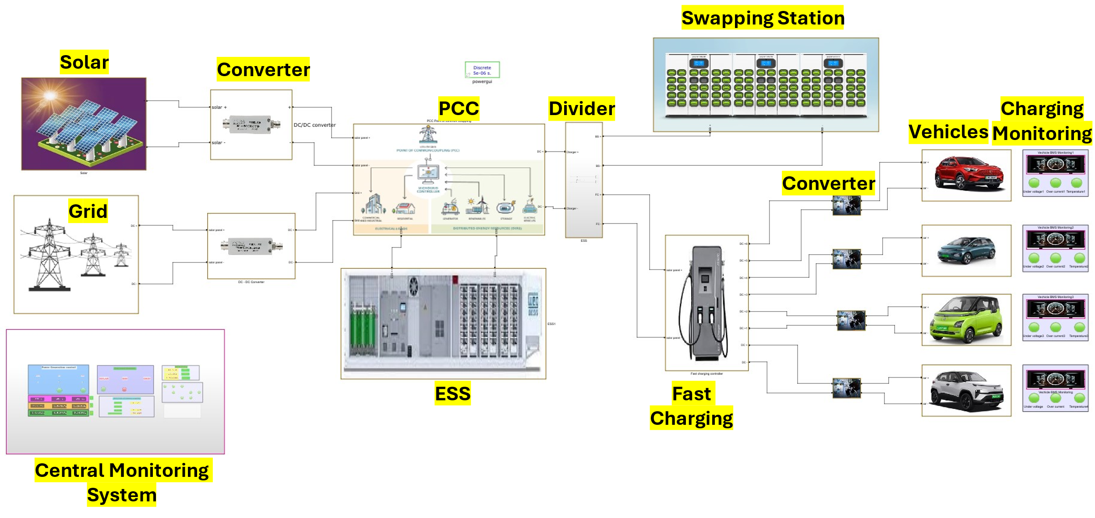
Figure 1 : Simulation of Battery Charging Management system on MATLAB

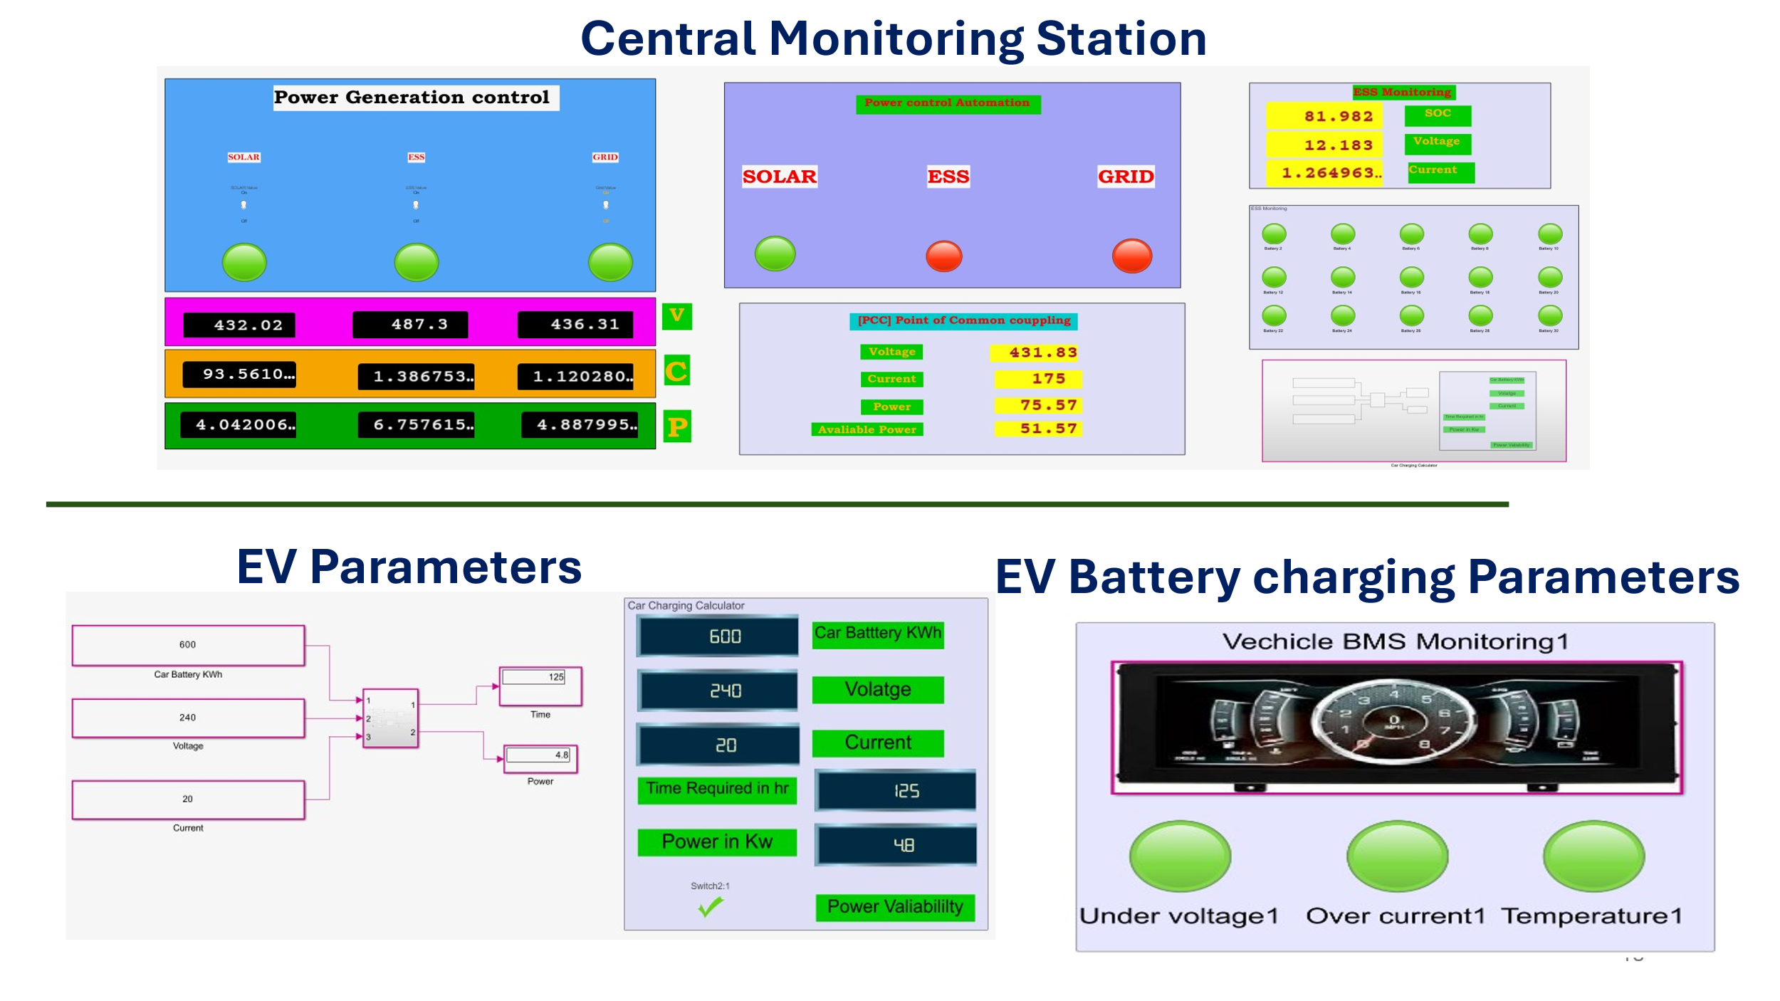
Figure 2 : Central Monitoring Station Figure : 3 Visualization Dash Board with Node-Red

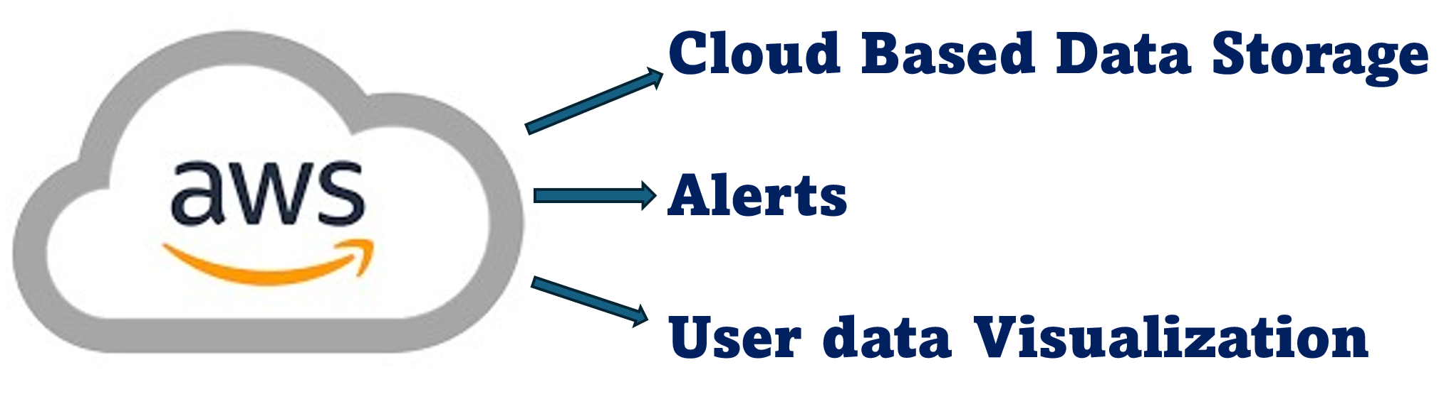
Figure: 4 - Integration of Cloud

The integration of solar energy, energy storage systems (ESS), and grid connections at the Point of Common Coupling (PCC). It highlights how these energy sources work together to automate charging based on availability and demand, supporting two main loads: a battery swapping station and four units of DC fast charging stations as shown in figure 1. The central monitoring station responsible for controlling all charging units. It emphasizes the system's capability to oversee operations, ensuring efficient management of energy distribution and load balancing across various charging stations as shown in figure 2. The user interface created using Node-Red for data visualization shown in figure 4. This interface allows users to monitor real-time data, track energy consumption, and manage charging schedules effectively, enhancing user engagement and operational efficiency and the cloud integration aspect of the system, figure 3 is showcasing how data is stored and processed in the cloud. It enables remote access to information, facilitates analytics, and supports decision-making processes based on real-time data from the charging infrastructure.

- Provide details concerning experimental data. (complete experimental procedure including list of experiments or trials conducted)

- The Simulation experimental procedures collectively demonstrate the functionality and effectiveness of the IoT architecture in managing battery charging systems while optimizing energy use from multiple sources. The results indicate significant improvements in efficiency, cost savings, and user experience in electric vehicle charging infrastructure.

- The first set of experiments focused on integrating various energy sources, including solar energy, energy storage systems (ESS), and grid power. The solar panels were tested to determine their daily energy output, which was measured at 1032 kW/day (56.8%), while the ESS contributed 576 kW/day (31.7%), and grid power supplied 209 kW/day (11.5%). These values were essential for understanding the overall energy generation capabilities of the system.

- Four automation conditions in PCC for automation were established to manage energy distribution effectively, each condition was tested to evaluate how well the system could adapt to varying levels of energy availability and demand.

- The system was tested with two main loads: a battery swapping station and four DC fast charging stations. The battery swapping station was designed to charge 90 batteries per day (54 kW/day), while the DC fast charging stations were assessed for their performance under different vehicle charging parameters.

- These experiments included setting up a central monitoring station that utilized Node-Red for data visualization. This dashboard allowed real-time monitoring of energy consumption and system performance metrics.

- The system's cloud integration was evaluated by connecting it to AWS for data storage and analytics. Various tests were conducted to ensure that data could be securely stored and accessed remotely, facilitating effective decision-making based on real-time data.

- The efficiency of renewable energy usage was calculated by comparing renewable energy output against total energy consumption. The energy saving efficiency was determined to be 88.6%, while cost-saving efficiency calculated from operational costs showed an efficiency of 88.5%.

- The potential revenue from the battery swapping station and DC fast charging stations was analysed, estimating daily revenue generation of approximately ₹29,494 after deducting grid power costs.

What is claimed?

- By intelligently managing energy sources and adapting to real-time demand, the system significantly improves the efficiency of the charging process, reducing wait times and energy waste.
- Utilizing renewable energy sources helps lower operational costs associated with EV charging. The predictive maintenance capabilities also reduce maintenance expenses by addressing potential issues before they lead to failures.
- The integration of renewable energy into the charging process contributes to a more sustainable transportation ecosystem, reducing greenhouse gas emissions and promoting cleaner air quality.
- The ability for users to customize charging schedules and preferences enhances their experience by providing flexibility in how and when they charge their vehicles.
- By participating in demand response programs, the system helps stabilize the electrical grid during peak demand periods, contributing to overall grid reliability and efficiency.
- The cloud-based architecture allows for easy scalability as the number of electric vehicles and charging stations increases, making it suitable for both small-scale deployments and large-scale infrastructure projects.

- Please list any publications (including abstracts, posters, news releases, etc.) in print or anticipated. Please state the date, place, and circumstances of such disclosures.

NA

- Identification of Inventor(s)
- Dr. Sujith Kalluri
- Mr. Jagadeeswara Chandra bose. K
- Applicants:

SRM University-AP

Signature of inventor(s) and date


07-01-2025


08-01-2025

